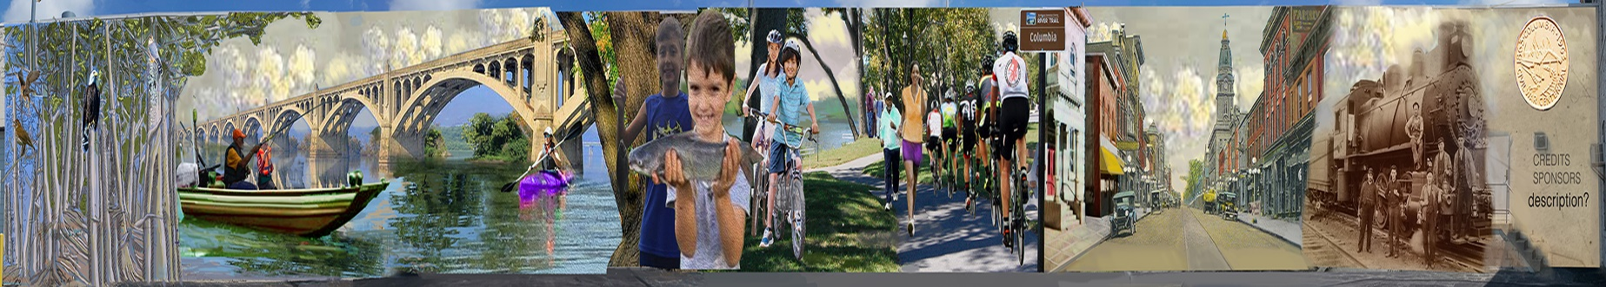
Be a Part of the Columbia Mural Project Become a Sponsor!
Beautifying an industrial area
Bringing large scale permanent outdoor public art to Columbia
Tourism Attraction

The Columbia Economic Development Corporation (CEDC) is installing a large-scale mural on the Front Street facing wall of the Eastern Drillers Manufacturing building. Have you seen what has already been installed?
The building at Front and Walnut Streets sits at the trailhead of the Northwest River Trail and across the street from Columbia Crossing and River Park – locations which attracts thousands of outdoor enthusiasts for hiking, biking, boating and fishing. The mural is a collage of themes including historic images, nature and the river, and people enjoying outdoor activities. This project is being led by a muralist with over 20 years’ experience in large scale mural art projects.
Eastern Drillers Manufacturing has agreed to the long-term use of their wall for the mural. Skilled preparation and application will insure a quality mural for 20+ years.
Total project costs which are very competitive with other murals completed in Southcentral and Eastern PA are $50,000 of which we’ve already raised $40,000.

CEDC is seeking your support for this project!
Contact Janice Nikoloff, CEDC, Executive Director
717-940-0946
Columbiaedcorp@gmail

